**Parameter Experiment**

Laura Scoble a, Simon J. Ussher a, Mark F. Fitzsimons a, Lauren Ansell b, Matthew Craven b, Ralph M. Fyfe a

a *School of Geography, Earth and Environmental Sciences, University of Plymouth, Plymouth, PL4 8AA, UK.*

*b School of Engineering, Computing and Mathematics, University of Plymouth, Plymouth, PL4 8AA, UK.*

**1. Introduction**

A previous critical literature review demonstrated inconsistencies in how FT-IR microspectroscopy had been applied across different studies, in particular the parameters used to generate spectra (particularly the scan rate and resolution). To address the impact of this inconsistency and address a knowledge gap in identifying the best approach, experiments were undertaken using replicate measurements from a single bulk sample from *Molinia caerulea*. This section presents the results from this methodological experimentation and suggests recommendations for standardised practice.

Two experiments were conducted, the first focussed on scan rate and the second on resolution (cm-1). The set-up variable was five different scan rates (16,32,64,128 and 256) and three resolutions (2, 4 and 8cm-1).

**2. Methods**

*2.1 Sample preparation*

Fresh *Molinia caerulea* was collected from Northumbria Wildlife Trust, UK and used to create a bulk sample. Pollen grains were obtained by extracting four anthers from individual heads using tweezers and delicately scrapped out onto one half of a diamond anvil slide using a needle and scalpel. Pollen grains were compressed between the two halves of the anvil and then examined to see which half had the most sample.

*2.2 Chemical Analysis*

The Bruker Vertex 70 FT-IR bench unit with infrared microscopy on the Hyperion 1000 was used to take ten replicate scans for each different parameter per experiment. Spectra recording was conducted between 4000 – 500 cm-1 and generated using Bruker OPUS vers.4 software. Scans were exported as .csv files and manipulated within R v. 3.1.4 (Team, 2022). Packages ggplot2 (Wickham, 2016) and tidyr (Wickham & Girlich, 2022) were used to plot spectra. Average spectra were created to plot the second derivatives in Origin (OriginLab, Northampton, MA, USA); for the purpose of these results, a smoother was not used.

*2.3 Data Analysis*

Data analysis was conducted on both scan rate and resolution data in R v.3.1.4 (Team, 2022), and focused on a specific wavenumber (scan rate and resolution: 1654 cm-1) to compare and evaluate whether there was a significant statistical difference between each parameter. Mean absorbance units were calculated for each and plotted onto a boxplot for visual analysis. Null hypothesis stated (H­0): all mean values were equal; the alternative hypothesis stated (H1): not all mean values were equal. If all mean values were equal then there was no significant difference between the scan rates/resolution and changing the number didn’t influence the overall spectrum. However, if all mean values weren’t equal then it was concluded that there was a significant difference between the scan rates/resolution, which indicated that changing the number influenced the overall spectrum.

A one-way ANOVA model was used to determine whether the mean values across each parameter were equal (*P = <0.05)*, which provided quantification of whether increasing scan rate/resolution was significant and affected the overall spectrum. Tukey honestly significant difference (HSD) test was performed for pairwise comparison between means. A confidence level of 95% (>0.05) was used, the p adj value (p-value) indicated whether there was a statistically significant difference between each pair or not. TukeyHSD test results were then manipulated, packages dplyr (Wickham, et al., 2023), multcomp (Hothorn, et al., 2008), emmeans (Lenth, 2023) and stringr (Wickham, 2022) was used to plot the data as a Compact Letter Display boxplot.

Full parameter methodology flowchart can be seen below (Figure SM1).

*Figure SMI.1: Parameter methodology flowchart* (Scoble, 2023)

**3. Results**

*3.1 Scan rate*

Five different scan rates are presented in Figure SM1.2: 16 (A), 32 (B), 64 (C), 128 (D) and 256 cm-1 (E) of *Molinia caerulea*. Lower scan rate numbers (A, B, C) exhibit higher scattering and noise, whereas the higher scan rates (D and E) are more detailed and smoother (Figure SM1.3). The broad -OH stretch (3300cm­-1) has reduced noise exhibited in D and E, with the asymmetric CH­2 (2923 and 2854cm-1) stretch exhibiting peak separation compared to the shouldering seen in A, B and C. The fingerprint region has a stronger level of absorbance in D and E, with C-O stretch (1163 and 1041cm-1) becoming more pronounced as the scan rate increases.

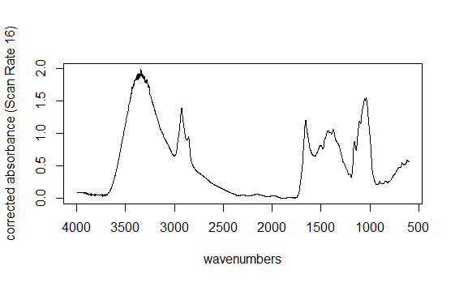

Wavenumber (cm­­­­­-1)

**A**

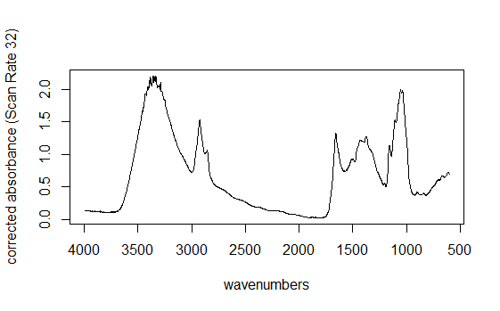

Wavenumber (cm­­­­­-1)

**B**

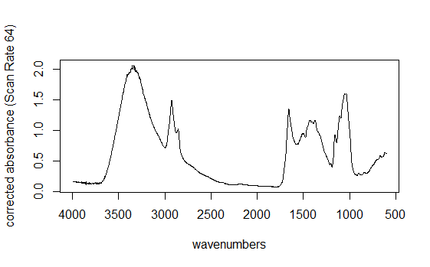

Wavenumber (cm­­­­­-1)

**C**

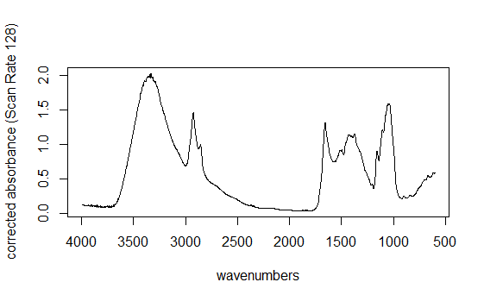

Wavenumber (cm­­­­­-1)

**D**

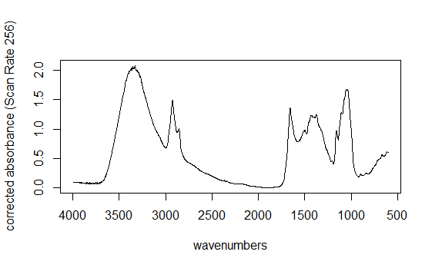

Wavenumber (cm­­­­­-1)

**E**

Absorbance Units

Absorbance Units

Absorbance Units

Absorbance Units

Absorbance Units

*Figure SM1.2: 10 replicate scans of scan rate 16 (A),32 (B),64 (C),128 (D) and 256 (E) of Molinia caerulea, averaged and plotted using R.*

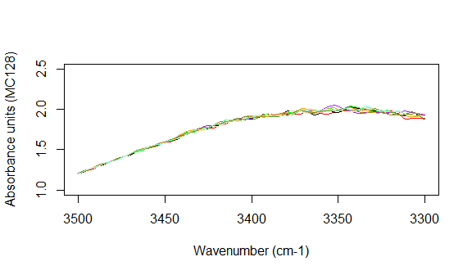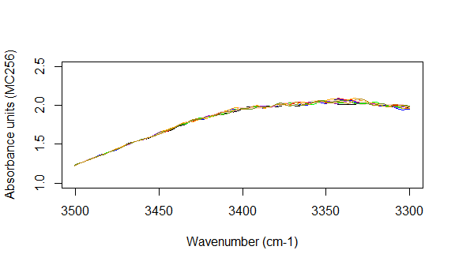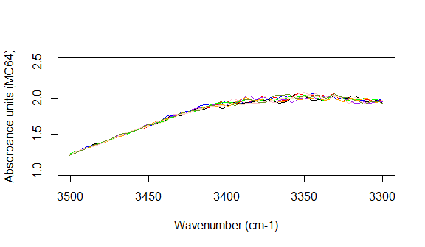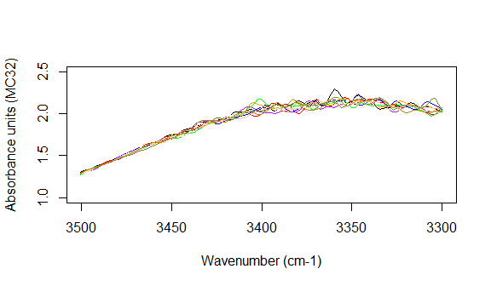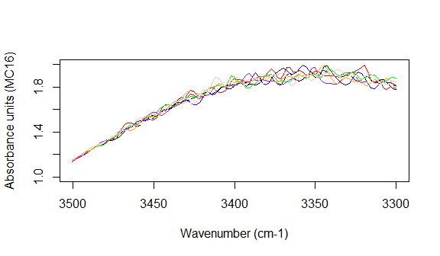

Wavenumber (cm-1)

Wavenumber (cm-1)

Wavenumber (cm-1)

Wavenumber (cm-1)

Wavenumber (cm-1)

**A**

**B**

**C**

**D**

**E**

Absorbance Units

Absorbance Units

Absorbance Units

Absorbance Units

Absorbance Units

*Figure SM1.3: Scattering of -OH peak at 3350 cm-1 at different scan rates: 16 (A),32 (B),64 (C),128 (D) and 256 (E) of Molinia caerulea.*

*3.1.2 Second Derivative*

Figure SM1.4 presents second order derivatives of the scan rates, providing greater signal enhancement for chemical bands. There are similarities amongst all the scan rates, with key functional groups being present throughout and resolved peaks pointing downwards. As the scan rate increases the noise exhibited before at the -OH stretch (3300cm­-1) reduces, with the broad band becoming nearly fully suppressed to baseline. Sharper upturned peaks between 1700-1500cm-1 (C=O and C=C stretch) can be seen throughout Figure SM1.4 with D and E having more distinct separation between 1250-1000cm-1 (C-O). The use of second order derivatives has highlighted a new peak shown at roughly 2400 cm­-1, indicative of a weak C≡N nitrile. Downturned peaks at roughly 900, 800 and 700 cm-1 are more recognisable as aromatic rings and can be associated with sporopollenin bands.

*Figure SM1.4: Second derivates of scan rates 16 (A),32 (B),64 (C),128 (D) and 256 (E) of Molinia caerulea.*

.

*3.1.3 Data Analysis*

Mean absorbance unit values for each scan rate were calculated by selecting a specific wavenumber from the fingerprint region (1654cm-1) and tabulating the corresponding absorbance units for each replicate scan. The variable absorbance unit value depended on the variable scan rate; therefore, absorbance unit was treated as the dependant variable and the scan rate as the independent variable.

*Figure SM1.5: Boxplot of scan rate mean absorbance unit values.*

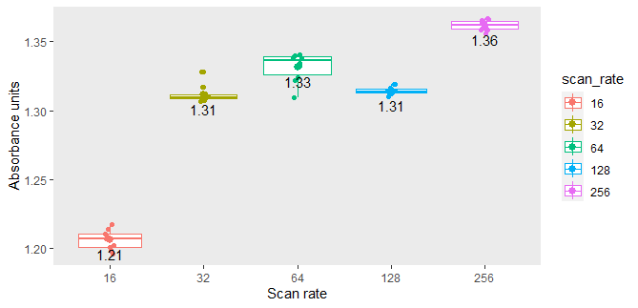

Scan Rate

Figure SM1.5 shows box plots of the five scan rates and the mean absorbance unit values. There is a noticeable increase in absorbance unit mean value as the scan rate is increased to 64, then gradually decreases to 128 and then increases again at 256. 32 and 128 have the same mean value (1.31), suggesting there is no difference between both scan rates. 16 has a short boxplot with longer whiskers, indicating a wide distribution of data compared to 32, 128 and 256. 32 exhibits a thin box plot and wider scattering, with two outliers at 1.320 and one at 1.316. 64 has the widest box plot with scattered data, indicating variance within absorbance unit values for 1654cm-1. 128 exhibits tight clustering with a thin box plot, indicating less variance within the data compared to between scan rate groups. 256 has the highest mean value (1.36) and a thin box plot with tight clustering, most of the data points are plotted around the mean.

An ANOVA test was run to determine whether the mean values were significantly different from one another, working on the H0 hypothesis that all mean values were equal, indicating there was no significant difference between scan rates. The *p-*value was “1.503903e-40” (1.503903 × 10-40) which was <0.05, concluding that the mean values were significantly different from one another. A Tukey Honestly Significant Difference (TukeyHSD) test was used for pairwise comparisons. All pairs apart from 128-32 had a *p* adj value of “0.0e+00”, which was <0.05%, indicating that there was a significant difference between each scan rate. 128-32 had a *p*-adj value of “0.8971323”, which was >0.05, indicating no significant difference between 32 and 128. A Compact Letter Display (CLD) A graph with colored rectangles
method was used to clarify the ANOVA and Tukey test output (Figure SM1.6).

*Figure SM1.6: Compact Letter Display (CLD) Boxplot of scan rate numbers, lowercase letters indicate significant difference between scan rate numbers*

Each scan rate had a specific lowercase letter and indicated that there is a statistically significant difference between all pairs of scan rates except 128-32. Therefore, null hypothesis (H0) is rejected and alternative (H1) is used concluding that changing the scan rate has an overall effect on the spectrum.

*3.2 Resolution*

Below are three different resolutions (Figure SM1.7):2cm-1 (F), 4cm-1 (G)and 8cm-1 (H) using a scan rate of 256. F displays a noisy spectrum with a non-linear spectral line. Bands are well defined, but some appear to be sharp instead of broad because of the excess noise, e.g., -OH stretch (3300(cm-1). The fingerprint region has some recognisable bands, however, the C=C shouldering at roughly 1500cm-1 is challenging to identify. G has considerably less noise across the spectrum. Peaks and shoulders can be clearly differentiated as the spectral line looks more linear. The start of the spectrum is closer to the baseline and more distinguishable. H has a non-linear spectral line with weak absorbance. Bands are challenging to identify, especially within the fingerprint region, e.g. the anti-symmetric CH2 bend (1433cm-1) and symmetric CH­­3 bend (1373cm-1). At the very end of the spectrum, the peaks dip below 0 absorbance.

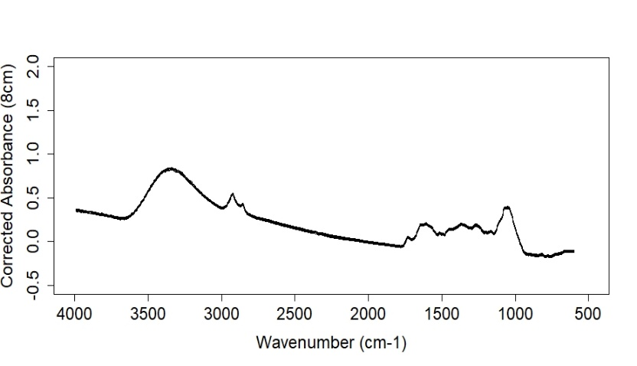

Wavenumber (cm-1)

**H**

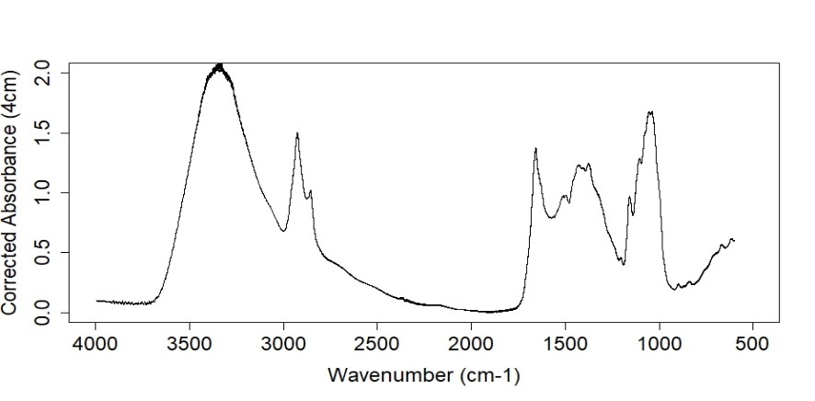

Wavenumber (cm-1)

**G**

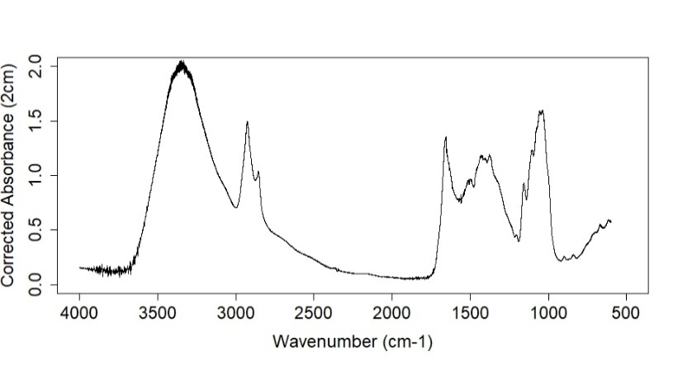

Wavenumber (cm-1)

**F**

Absorbance Units

Absorbance Units

Absorbance Units

*Figure SM1.7:10 replicate scans of resolution 2 (F), 4 (G) and 8cm-1(H) of Molinia caerulea, averaged and plotted using R.*

*3.2.1 Second derivatives*

 Figure SM1.8 presents second derivatives for the resolutions (cm-1). All three have very different absorbances, with F having the strongest and noisiest spectrum. F exhibits full supression of the -OH stretch (3300 cm-1), asymmetric CH­2 stretch (2923 and 2854 cm-1­­) and the C-O stretch (1163 and 1041 cm-1). More obscure peaks cannot be identified as the spectrum is compacted. G exhibits a familiar spectrum with resolved peaks pointing downwards and a more defined fingerprint region. Strong C=C bands at roughly 1600cm-1 and C-O stretches between 1100-1000cm-1 are presented. Upward peaks can be seen between 1700-1600 cm-1 and 1200-1100 cm-1, indicative of a C=O and C-O stretch, respectively. Noise is still present at the beginning of the spectrum but not as strong. H has wider spacing between peaks, and very strong peaks. Resolved peaks have a strong negative absorbance with the asymmetric CH2 stretch (2854 cm-1) measured at -0.0008. More pronounced upturned peaks are exhibited between 1400-1250cm-1, which could be indicative of symmetric CH3 stretch.

*Figure SM1.8: second derivatives of resolution 2 (F), 4 (G) and 8cm-1(H) of Molinia caerulea*

*3.1.3 Data analysis*

Mean absorbance unit values for each resolution (cm-1) were calculated by selecting a specific wavenumber (1654 cm-1) and tabulating the corresponding absorbance units for each replicate scan. The variable absorbance unit value depends on the variable resolution; therefore, absorbance unit is treated as the dependant variable and the resolution as the independent variable.

*Figure SM1.9: Boxplot of resolution mean absorbance unit value.*

Figure SM1.9 shows box plots of the three resolution numbers and the mean absorbance unit values. There is a subtle increase in absorbance unit value as the resolution is increased, until a rapid decrease between 4cm-1 and 8cm-1. 2cm-1 and 4cm-1 exhibit tight clustering of data with thin box plots, indicating less variance within. 8cm-1 has the lowest mean value of 0.16 and clustering dispersion is more spread out indicating more variance in the data.

An ANOVA test was run to determine whether the mean values were significantly different from one another. The *p-*value of the resolutions was “3.763198e-55” (3.763198× 10-55) which is <0.05, concluding that the mean values are significantly different from one another. A Tukey Honestly Significant Difference (TukeyHSD) test was used for pairwise comparisons All pairs apart from 4-2 (7.7e-06) had a *p* adj value of “0.0e+00” which is <0.05%, indicating that there is a significant difference between each pair of resolutions (cm-1). A Compact Letter Display (CLD) method was used to clarify the ANOVA and Tukey test A white rectangular object with red green and blue lines
output (Figure SM1.10).

.

*Figure SM1.10: Boxplot of resolution (cm-1) numbers, lowercase letters indicate significant difference between resolution (cm-) numbers*

Each resolution (cm-1) has a specific lowercase letter, and indicates that there is a statistically significant difference between all pairs. Therefore, null hypothesis (H0) is rejected and alternative (H1) is used concluding that changing the resolution (cm-1) has an overall effect on the spectrum.

**4. Discussion**

Most analytical studies operationally define measurement parameters such as scan rate and resolution (Barra, et al., 2021), or base it on the suppliers’ recommendations. Software such as Bruker OPUS spectroscopy provides spectrum acquisition for numerous analytical instruments, e.g Bruker Hyperion 1000 FT-IR Microscope. This includes scan rate and resolution measurement parameters but provides no in-depth explanation as to why these specific parameters have been chosen. Research surrounding FT-IR microspectroscopy pollen identification suggest the optimal parameters are 256 scan rate and 4cm-1 resolution (Julier, et al., 2016)(Jardine, et al., 2019)*.* However, as discussed in chapter 7’s systematic review, there were inconsistencies in how the scan rate and resolution had been used to generate spectrum using FTIR microspectroscopy. To address the knowledge gap, experiments were undertaken on scan rate and resolution using ten replicate measurements from a bulk sample and from a single species (*Molinia caerulea*) to find the optimal parameters.

When analysing organic material, scan rates are crucial; the higher the scan rate, the more scans are performed. After 50 scans, the spectrum acquisition noticeably improves, with influential absorption bands becoming more prominent in the "fingerprint region." As shown in Figure SM1.2 and Figure SM1.3’s comparison of the scan rates, 256 (E) has less noise and scattering. It exhibits a smooth spectrum with prominent peaks, essential for analysing functional groups for identification. While 64 (C) and 128 (D) exhibit a smooth spectrum in comparison to 16 (A) and 32 (B), 256 (E) offers additional detailing, such as pronounced shouldering and easier functional group recognition.

Figure SM1.4 presents the conversion of scan rate spectra into second derivatives. Second derivatives aid in chemical band interpretation, as it can resolve overlapping analyte signals by enhancing the signals within vibrational spectra (Kohler, et al., 2020). There were similarities across all five scan rates with resolved broad peaks pointing downwards. As scan rate increases, there is a gradual reduction in noise and sharp peaks before the -OH stretch (3300cm-1). Upturned peaks separate out clearer in 128 (D) and 256 (E) compared to 16 (A), 32 (B), and 64 (C) between 1700-1500cm-1 and 1250-1000cm-1. Comparing this to Figure SM1.2, 128 (D) and 256 (E) have more pronounced peaks at roughly 1650cm-1 (C=C) and shouldering between 1150-1000cm-1 (C-O). A new peak at roughly 2300cm-1 appeared within the second order derivatives, this could be indicative of a weak C≡N stretch as the peak was obscured across Figure SM1.2.

Resolution is considered as “*the ability to separate two spectral lines that are very close in wavelength or frequency”* (Schlindwein, 2020)*.* If two IR absorption bands are similar, the resolving power must be increased to separate them. Typically, the type of material being analysed determines the resolution number. Since the absorption bands are narrow for gases, the vibration of the atoms is measured at a wavelength of 0.2 to 0.5 cm-1. As solids and liquids have wide absorption bands, choosing a value lower than 2cm-1 would not provide any more information (Schlindwein, 2020).

Figure SM1.7 exhibits the resolution spectra and demonstrates that there is greater noise with a non-linear spectral line when the number is reduced to 2cm-1 (F). Noise can be decreased by scanning the sample immediately after the background scan. Lowering the resolution lengthens the time between scans, increasing the likelihood of noise. A background scan would have to be conducted more frequently if 2cm-1 resolution was used, making this less time efficient. Absorption bands are well defined, but some appear sharp instead of broad, e.g, -OH stretch (3300(cm-1). Across the fingerprint region, bands are distinguished, however, the C=C shouldering at roughly 1500cm-1 is challenging to identify. Comparing this to 4cm-1 (G), the spectral line is deemed linear as there is a reduction in noise. Peaks and shoulders can be clearly differentiated, and the start of the spectrum is closer to baseline. 8cm-1 (H) has a non-linear spectral line with weak absorbance. Increasing the resolution shortens the time between scans, decreasing the degree of fineness obtained (Ota, 2007). Chemical signals are difficult to identify especially within the fingerprint region, e.g the anti-symmetric CH2 bend (1433 cm-1) and symmetric CH­­3 bend (1373 cm-1). At the very end of the spectrum the peaks dip below 0 absorbance. If this was seen across the other resolution spectra, this could be indicative that the background scan was taken incorrectly or the ATR cell wasn’t cleaned sufficiently beforehand. However, as the negative absorbance is only present in 8cm­-1 (H) fingerprint region, it is highly probable that this is a result of the lack of resolving power and detail.

When stacking and comparing the spectra (Figure SM1.11), it is visually clear that 4 cm-1 resolution (red) compared to 2 cm-1 provides a smooth spectrum with negligible noise between 4000-3500cm-1, the -OH peak at 3300cm-1, and the fingerprint region. When compared to 8cm-1 resolution (blue), the spectrum is barely distinguishable.

*Figure SM1.11: Average scans of resolution 2,4 and 8cm-1 of Molinia caerulea.*

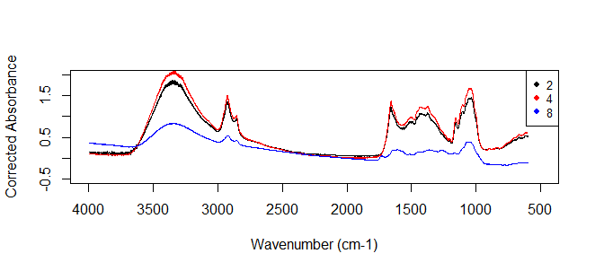

Wavenumber (cm-1)

Absorbance Units

Figure SM1.8 presents the conversion of resolution spectra into second order derivatives. All three have very different strengths of absorbance, with 2cm-1 (F) having the strongest and noisiest spectrum. As stated previously, increasing the resolution increases the likelihood of noise. One way to decrease noise would be to use a smoothing algorithm such as the Savitzky-Golay. This multifunctional pre-processing algorithm can be used for noise-reduction through the function of smoothing (Savitzky & Golay, 1964). It defines a moving window which smooths out the spectrum, increasing the window size causes the smoothing intensity to intensify. However, this can lead to loss of valuable chemical information and analyte signals (Kohler, et al., 2020). Figure SM1.12 is an example of using the Savitzky-Golay smoothing feature on 4cm-1 (G) second order derivative (black). A window size of 9 (red) and 17 (green) was used with a polynomial of 2.

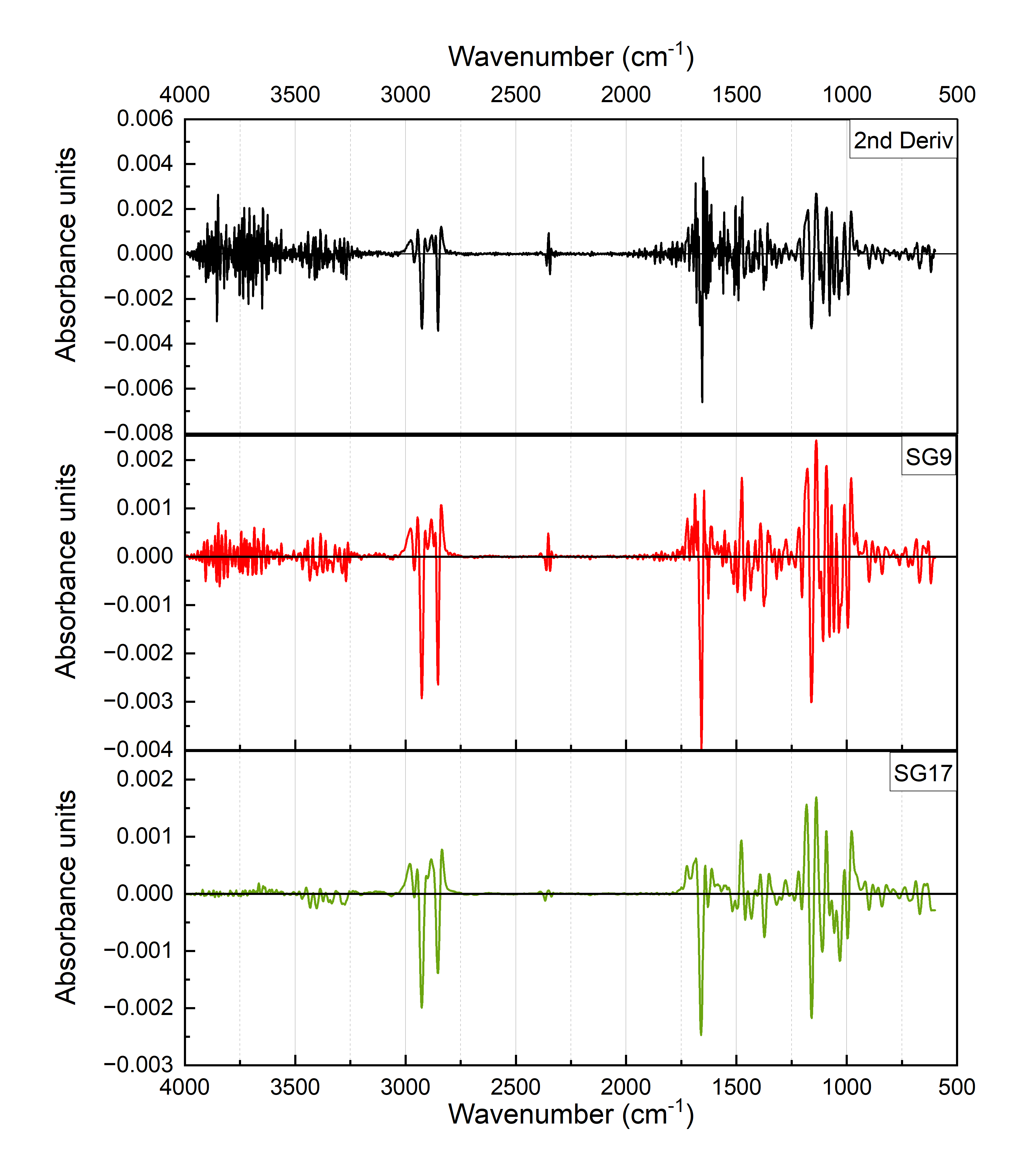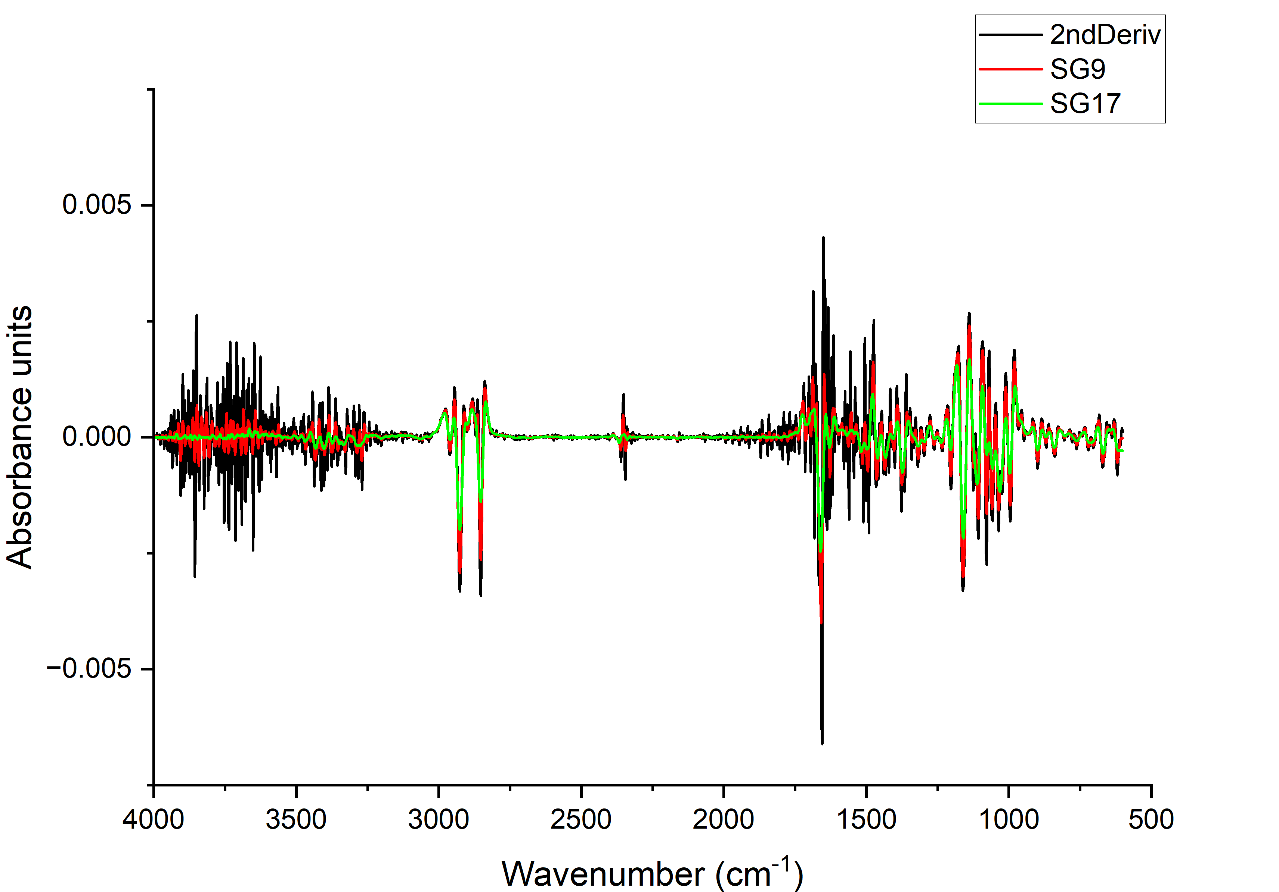

*Figure SM1.12: Multiple line plot (a) and stacked line plot (b) of resolution 4cm-1 (G) second order derivative (black), Savitzky-Golay (SG) smoothing – window size 9 (red) and size 17 (green).*

Across Figure SM1.8 and SM1.12, 4cm-1 (G) exhibits a familiar spectrum with resolved peaks pointing downwards and a more defined fingerprint region. It has a greater level of detail compared to 8cm-1 (H), but not an excess where the spectrum becomes noisy and hard to interpret as seen in 2cm-1 (F). Comparing line plots (Figure 8.13 (a/b)), the second order derivative spectral line (black) is noisy whereas the two SG lines (red)(green) display distinct peaks. SG9 (red) presents strong downturned resolved C=C bands at roughly 1600cm-1 and C-O stretches between 1100-1000cm-1. Noise is still present at the beginning of the spectrum but not as strong The -OH stretch (3300cm-1) has been slightly suppressed but is still identifiable, whereas SG17 (green) has suppressed it more intensively. This suppression is a clear example of loss of chemical information as a direct result of a larger window size. While SG17 (green) has over-suppressed resolved peaks, the fingerprint region has excellent separation between upturned peaks. Peaks can be identified between 1700-1600cm-1 and 1200-1100-1, indicative of C=O and C-O stretches. The application of the Savitzky-Golay algorithm across IR spectra can be beneficial if absorbance bands are difficult to distinguish. However, users must be cautious when choosing a window size as this could lead to an over supression of analyte signal and ultimately loss of chemical information.

Data analysis of both scan rate and resolution indicated that there is a statistically significant difference when the numbers are changed. Increasing the scan rate saw an overall increase in the mean absorbance values, clustering of data also became more compact with less range (Figure SM1.5). The linear model (*p-*value: 2.2e-16) and ANOVA (*p*-value: 1.503903e-40) tests output indicated that there was a significant difference between the scan rates mean values (*p*-value: <0.05). Tukey test and CLD method (Figure SM1.6) was used to clarify these outputs by comparing pairs, determining that all pairs of scan rates apart from 128-32 were significantly different as the *p*-adj was <0.05. 128-32 had a *p-*adj value of “0.8971323”, concluding that this pair is not significantly different. Therefore, the null hypothesis (H0) is rejected, and the alternative (H1) is used, signifying that increasing the scan rate makes a significant difference in the overall spectrum. When comparing 16, 64, and 256 to determine which scan rate offers the best consistency and less variance, 256 has the thinnest box plot with tighter clustering of data. Along with less range compared to 16 and 64, this indicates less variance within 256’s dataset compared to variance between groups.

Changing the resolution (cm-1) exhibited similar results (Figure SM1.9). While the difference between 2cm-1 (1.35) and 4cm-1 (1.36) mean absorbance values wasn’t visually significant, 8cm-1 saw a rapid decline to 0.16. Clustering also became less compact as the resolution was increased from 4cm-1 to 8cm-1,suggesting data became more variable within the group. The linear model (*p-*value: 2.2e-16) and ANOVA (*p-*value: 3.763198e-55) tests output indicated there was significant difference between the resolution mean values (*p*-value: <0.05). Tukey test and CLD method was used for pairwise comparisons, determining that all resolution pairs were significantly different from one another as the *p*-adj values were <0.05 (Figure SM1.10). Therefore, the null hypothesis (H0) is rejected, and the alternative (H1) is used, signifying that increasing the resolution significantly affects the overall spectrum. However, 8cm-1 sees wider variance (Figure SM1.9) and loss of chemical information (Figure SM1.7), whereas 2cm-1 has tight clustering (Figure SM1.9) but an incredibly noisy spectrum making identification difficult (Figure SM1.8F). 4cm-1 has tight clustering, a thin boxplot (Figure SM1.9) and identifiable peaks (Figure SM1.7 and SM1.8G), indicating less variance within the dataset and better consistency compared to the other two resolutions.

**5. Conclusion**

When altered, scan rate and resolution can affect the generated average spectrum. Understanding what the optimal parameters are for FT-IR pollen analysis will ultimately lead to a more successful identification of functional groups and classification. Scan rate is crucial as the more scans taken improves the spectrum acquisition, while increasing the resolution aids in separating two similar absorption IR bands. The combined systematic review, laboratory experiments and data analysis meant a comparison could be made between the analytical methods and chosen parameters against the results above. Overall, 256 scan rate and 4cm-1 resolution are the best parameters for pollen identification. The only published study that uses these parameters is Jardine et al (*2019*). 256 has reduced noise and scattering, exhibiting a smooth spectrum with prominent peaks - essential for analysing functional groups and identifying morphologically indistinct pollen families. 4cm-1 provides enough separation for IR absorption bands to be identifiable with minimal noise. To build reference libraries of spectra that can be shared and used by other researchers, the scan rate and resolution should be standardised using these parameters.

**5. Bibliography**

Barra, I. et al., 2021. Optimizing setup of scan number in FTIR spectroscopy using the moment distance index and PLS regression: application to soil spectroscopy. *Scientific Reports,* Volume 11, p. 13558.

Hothorn, T., Bretz, F. & Westfall, P., 2008. Simultaneous Inference in General Parametric Models. *Biometrical Journal,* 50(3), pp. 346-363.

Jardine, E. P. et al., 2019. Chemotaxonomy of domesticated grasses: a pathway to understanding the origins of agriculture. *Micropalaeontol,* Volume 38, pp. 83-95.

Julier, C. M. A. et al., 2016. Chemotaxonomy as a tool for interpreting the cryptic diversity of Poaceae pollen. *Review of Palaeobotany and Palynology,* Volume 235, pp. 140-147.

Kohler, A. et al., 2020. Model-Based Pre-Processing in Vibrational Spectroscopy. In: *Comprehensive Chemometrics.* s.l.:Elsevier, pp. 83-100.

Lenth, R., 2023. *emmeans: Estimated Marginal Means, aka Least-Squares Means.* [Online]   
Available at: https://CRAN.R-project.org/package=emmeans  
[Accessed 17 March 2023].

Ota, H., 2007. Resolution and Aperture. *FTIR Talk Letter Vol.8*, October, pp. 02-07.

Savitzky, A. & Golay, M. J. E., 1964. Smoothing and Differentiation of Data by Simplified Least Squares Procedures. *Anal. Chem,* p. 36.

Schlindwein, H. S., 2020. *About Spectral Resolution in FT-IR Spectroscopy.* [Online]   
Available at: https://www.opticsblog.bruker.com/guide-to-spectral-resolution-in-ft-ir/  
[Accessed 13 January 2023].

Scoble, L., 2023. *Parameter flowchart.* Plymouth: s.n.

Team, R. C., 2022. *R: a language and environment for statistical computing..* Vienna: R Foundation for Statistical Computing.

Wickham, H., 2016. *ggplot2: Elegant Graphics for Data Analysis.,* New York: Springer-Verlag.

Wickham, H., 2022. *stringr: Simple, Consistent Wrappers for Common String Operations.* [Online]   
Available at: https://CRAN.R-project.org/package=stringr  
[Accessed 17 March 2023].

Wickham, H. et al., 2023. *dplyr: A Grammar of Data Manipulation. R Package 1.1.0.* [Online]   
Available at: https://CRAN.R-project.org/package=dplyr  
[Accessed 15 March 2023].

Wickham, H. & Girlich, M., 2022. *tidyr: Tidy Messy Data.* [Online]   
Available at: https://CRAN.R-project.org/package=tidyr  
[Accessed 13 January 2023].